SKQ201713S Arctic Cod Summary Statistics:

\*\* These figures exclude the test station \*\*

Total Number of Trawls: 15

Total Number of Arctic Cod caught in trawl: 3649

Minimum length (measured, we did not measure the smallest ones): 45 mm

Maximum length: 288

Total Number of fish measured: 752

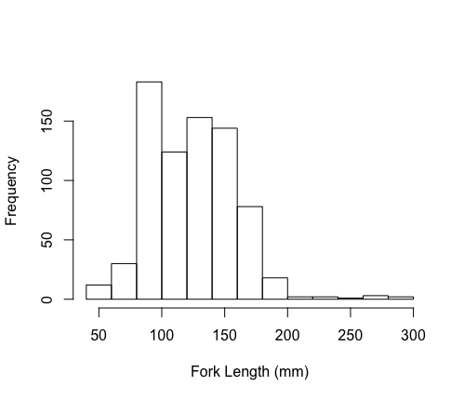

Number of stomachs sampled: 273

Number of livers sampled: 185

Number of muscle tissues taken: 195

Number of heads for otoliths: 195

Number of individual fish frozen whole (measured, then frozen in a bag with a label): 158

Number of RNAlater samples: 281

Postlarvae frozen from midwater trawl: 169

Slightly larger fish (~Age-1) frozen whole from midwater trawl: 187

\*\* This adds up to 356 additional fish frozen whole from the midwater trawls, I (Chrissy) feel less confident about the distinctions between postlarvae and not postlarvae

Other fish in midwater trawl (from water column tows only):

We froze 22 fish that we believe to be *Arctogadus*.

9 snailfish

5 myctophids

34 shrimp

1 fish that might have been a prickleback

Arctic cod postlarvae pulled from plankton samples:

Tucker Trawl: 895

Bongo: 170

Ring Net: 11

Total: 1080